ASSIGNMENT – 11
WILDCARD
- Write a SQL query to find the details of those salespeople who come from the 'Paris' City or 'Rome' City. Return salesman_id, name, city, commission.
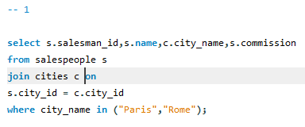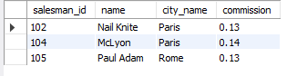
- Write a SQL query to find the details of the salespeople who come from either 'Paris' or 'Rome'. Return salesman_id, name, city, commission.
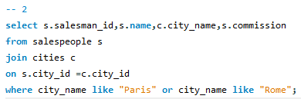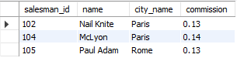
- Write a SQL query to find the details of those salespeople who live in cities other than Paris and Rome. Return salesman_id, name, city, commission.
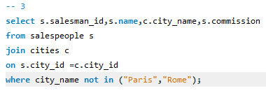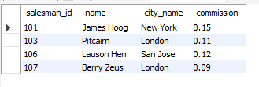
- Write a SQL query to retrieve the details of all customers whose ID belongs to any of the values 3007, 3008, or 3009. Return customer_id, cust_name, city, grade, and salesman_id.
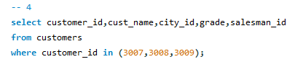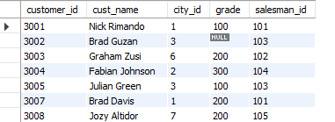
- Write a SQL query to find salespeople who receive commissions between 0.12 and 0.14 (begin and end values are included). Return salesman_id, name, city, and commission.
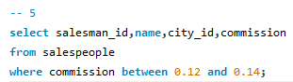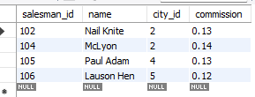

- Write a SQL query to select orders between 500 and 4000 (begin and end values are included). Exclude orders amounting to 948.50 and 1983.43. Return ord_no, purch_amt, ord_date, customer_id, and salesman_id.
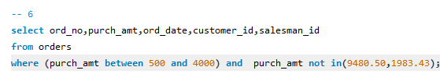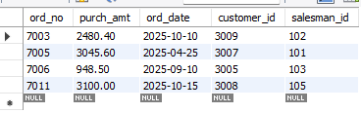
- Write a SQL query to retrieve the details of the salespeople whose names begin with any letter between 'A' and 'L' (not inclusive). Return salesman_id, name, city, commission.
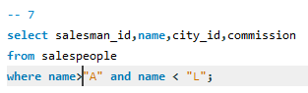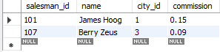
- Write a SQL query to find the details of all salespeople except those whose names begin with any letter between 'A' and 'L' (not inclusive). Return salesman_id, name, city, commission.
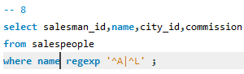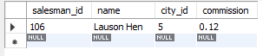
- Write a SQL query to retrieve the details of the customers whose names begin with the letter 'B'. Return customer_id, cust_name, city, grade, salesman_id..
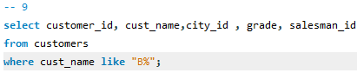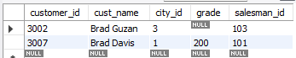
- Write a SQL query to find the details of the customers whose names end with the letter 'n'. Return customer_id, cust_name, city, grade, salesman_id.
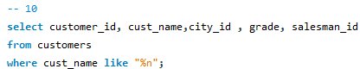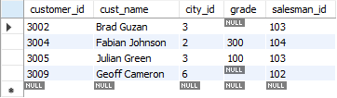
- Write a SQL query to find the details of those salespeople whose names begin with ‘N’ and the fourth character is 'l'. Rests may be any character. Return salesman_id, name, city, commission.
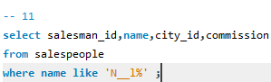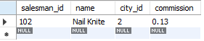
- Write a SQL query to find those rows where col1 contains the escape character underscore ( _ ). Return col1.
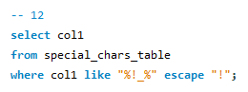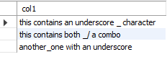
- Write a SQL query to identify those rows where col1 does not contain the escape character underscore ( _ ). Return col1.
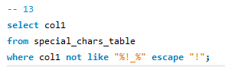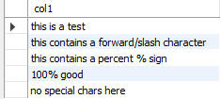
- Write a SQL query to find rows in which col1 contains the forward slash character ( / ). Return col1.
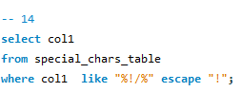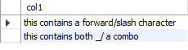
- Write a SQL query to identify those rows where col1 does not contain the forward slash character ( / ). Return col1.
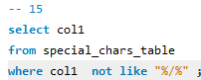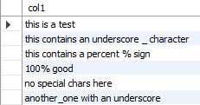
- Write a SQL query to find those rows where col1 contains the string ( _/ ). Return col1.
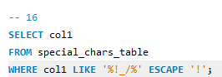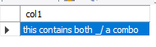
- Write a SQL query to find those rows where col1 does not contain the string ( _/ ). Return col1.
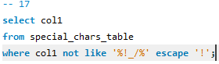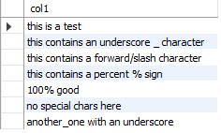
- Write a SQL query to find those rows where col1 contains the character percent ( % ). Return col1.
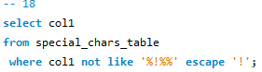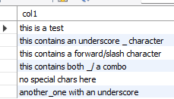
- Write a SQL query to find those rows where col1 does not contain the character percent ( % ). Return col1.
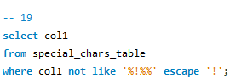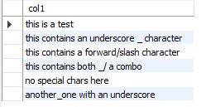
- Write a SQL query to find all those customers who do not have any grades. Return customer_id, cust_name, city, grade, salesman_id.
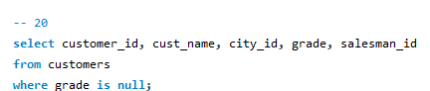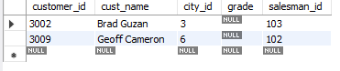
- write a SQL query to locate all customers with a grade value. Return customer_id, cust_name, city, grade, salesman_id.
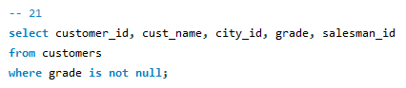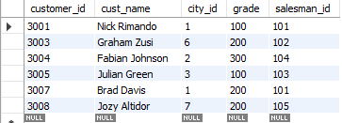
- Write a SQL query to locate the employees whose last name begins with the letter 'D'. Return emp_idno, emp_fname, emp_lname and emp_dept.
